Bahria University,

Karachi Campus

LAB EXPERIMENT NO.

04

LIST OF TASKS

|  |  |
| --- | --- |
| TASK NO | OBJECTIVE |
| **01** | Using python implement Decision Tree Algorithm on Diabetes Dataset the chances of diabetes in a person. visualize the results of the model in the form of a confusion matrix using matplotlib and seaborn. |
| **02** | Using KNIME implement Task # 01. |
| 03 | Using python perform the parameter tuning to optimize the Decision Tree performance and compare the results with task # 1. |

Submitted On:

13-03-2024

(Date: DD/MM/YYYY)

**Task No. 01**: Using python implement Decision Tree Algorithm on Diabetes Dataset the chances of diabetes in a person. visualize the results of the model in the form of a confusion matrix using matplotlib and seaborn.

**Solution:**

import pandas as pd

from sklearn.model_selection import train_test_split

from sklearn.tree import DecisionTreeClassifier

from sklearn.metrics import accuracy_score, classification_report, confusion_matrix

df = pd.read_csv("/content/diabetes (1).csv")

# Update the specified columns

selected_columns = ['Pregnancies', 'Glucose', 'BloodPressure', 'SkinThickness', 'Insulin', 'BMI', 'DiabetesPedigreeFunction', 'Age', 'Outcome']

df = df[selected_columns]

# Split the dataset into features (X) and target variable (y)

X = df.drop(columns=["Outcome"])

y = df["Outcome"]

# Split the dataset into training and testing sets

x_train, x_test, y_train, y_test = train_test_split(X, y, test_size=0.2, random_state=42)

# Initialize decision tree classifier with Gain Ratio

clf = DecisionTreeClassifier(criterion='entropy', splitter='best')

# Train the classifier on the training data

clf.fit(x_train, y_train)

# Make predictions on the testing data

y_pred = clf.predict(x_test)

# Evaluate the classifier

accuracy = accuracy_score(y_test, y_pred)

print("Accuracy:", accuracy)

# Print classification report

print("Classification Report:")

print(classification_report(y_test, y_pred))

# Print confusion matrix

print("Confusion Matrix:")

print(confusion_matrix(y_test, y_pred))

# Select the specified columns

selected_columns = ['Pregnancies', 'Glucose', 'BloodPressure', 'SkinThickness', 'Insulin', 'BMI', 'DiabetesPedigreeFunction', 'Age', 'Outcome']

df = df[selected_columns]

# Split the dataset into features (X) and target variable (y)

X = df.drop(columns=["Outcome"])

y = df["Outcome"]

# Split the dataset into training and testing sets

x_train, x_test, y_train, y_test = train_test_split(X, y, test_size=0.2, random_state=42)

# Initialize decision tree classifier with Gain Ratio

clf = DecisionTreeClassifier(criterion='gini', splitter='best')

# Train the classifier on the training data

clf.fit(x_train, y_train)

# Make predictions on the testing data

y_pred = clf.predict(x_test)

# Evaluate the classifier

accuracy = accuracy_score(y_test, y_pred)

print("Accuracy:", accuracy)

# Print classification report

print("Classification Report:")

print(classification_report(y_test, y_pred))

# Print confusion matrix

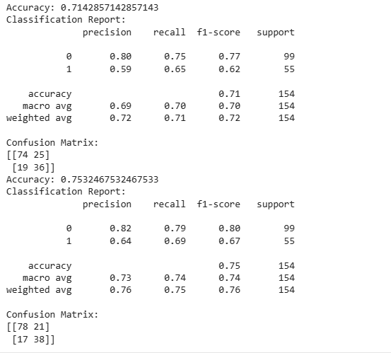print("Confusion Matrix:")

print(confusion_matrix(y_test, y_pred))

**Output:**

import matplotlib.pyplot as plt

import seaborn as sns

cm = confusion_matrix(y_test, y_pred)

plt.figure(figsize=(8, 6))

sns.heatmap(cm, annot=True, fmt="d", cmap="Blues", cbar=False)

plt.xlabel("Predicted Label", fontsize=12)

plt.ylabel("True Label", fontsize=12)

plt.title("Confusion Matrix", fontsize=14)

plt.xticks(rotation=45)

plt.show()

**Task No. 02**: Using Knime implement Task # 01.

**Solution:**

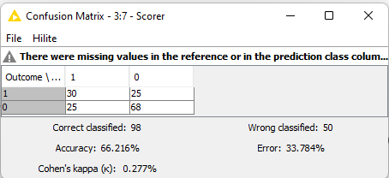**Output:**

**Task No. 03**: Using python to perform the parameter tuning to optimize the Decision Tree performance and compare the results with task # 1.

**Solution:**

from sklearn.model_selection import GridSearchCV

param_grid = {

    'max_depth': [5, 10, 20],

    'min_samples_leaf': [1, 2, 4],

    'min_samples_split': [2, 5, 10],

}

clf = DecisionTreeClassifier(criterion='gini', splitter='best')

grid_search = GridSearchCV(clf, param_grid, cv=5)

grid_search.fit(x_train, y_train)

print("Best parameters:", grid_search.best_params_)

best_clf = grid_search.best_estimator_

y_pred = best_clf.predict(x_test)

accuracy = accuracy_score(y_test, y_pred)

print("Accuracy:", accuracy)

print("Classification Report:")

print(classification_report(y_test, y_pred))

print("Confusion Matrix:")

print(confusion_matrix(y_test, y_pred))

**Output:**

